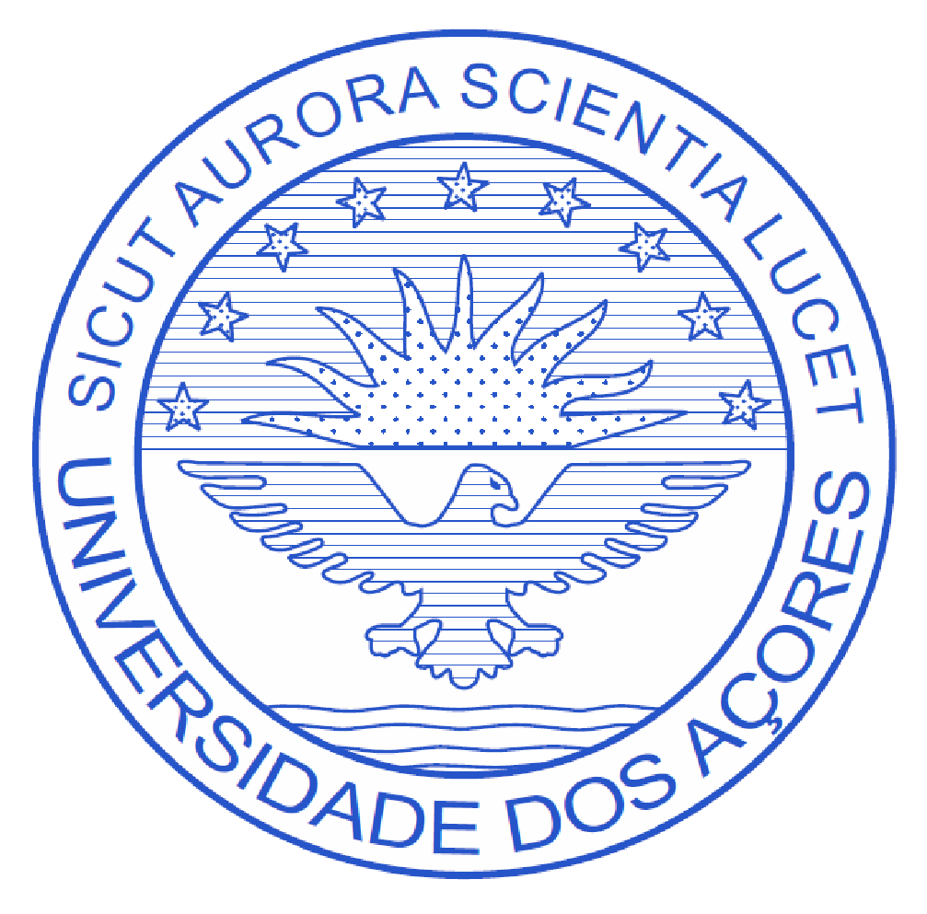
UNIVERSITY OF THE AZORES
Academic Syllabus 2026
- Course Name

- EN: The Living Archive of Place: History, Sustainability, and Art
- place as a living archive: history, sustainability and art.

2. Working hours / ECTS

Contact hours |  | Total working hours​ | ECTS | US Credits
Theoretical  Theoretical and practical  Laboratory  Seminar  Fieldwork​  Internship  Guidelines tutorials | 10  7  7  7  14  0  0 | 145 (USA equivalent 45) | 6 | 3

3. Teachers responsible for the course

Professor Emanuela Meidav / University of Massachusetts at Amherst
Email: emeidav@umass.edu

Doctor Eduardo José da Silva Tomé Marques
e-mail: eduardo.js.marques @uac.pt

Support administrative :
Laudalina Rosa Ponte Medeiros Estereiro , Senior Library Technician, American Corners
Email: laudalina.rp.esteireiro@uac.pt

4. Course description and context​
a) Context / rationale :
Islands occupy a critical position in contemporary debates on sustainability, climate change, and environmental justice. Their ecological vulnerability, combined with long histories of migration, relative autonomy, and social experimentation, makes them privileged contexts for observing processes of resilience, adaptation, and cultural innovation. The Azores archipelago, located on the Mid-Atlantic Ridge and marked by active volcanic geology, constitutes a living laboratory where ecology, economy, memory, community practices, and cultural production intersect.
This course proposes one approach academic interdisciplinary what articula Studies encompass sustainability , performing arts, community-based artistic practices, and place-based research methodologies. It is based on the principle that ecological and social knowledge is not only technical or scientific, but also narrative, sensory, and embodied. Listening to stories from the place implies recognizing local knowledge, intergenerational memories , and everyday practices as legitimate forms of knowledge production.
- Description course summary​
The Place as a Living Archive: History, Sustainability, and Art. Listening to Stories from the Place is a four-part course . The program lasts for weeks and combines fieldwork, theoretical seminars, practical workshops, and collaborative creative processes. Students explore the island of São Miguel through guided walks, visits to ecological infrastructure, and meetings with local stakeholders (artists, farmers, designers, researchers, and community organizations).
Drawing on methodologies from performance art, creative writing, ethnography, and narrative journalism, participants develop projects that result in public interventions, performances, exhibitions, or publications. The course emphasizes practices of active listening, environmental observation, and ethical engagement with local communities, promoting an understanding... situated within sustainability .

5. Calendar expected

Week 1:
- General presentation of the course and the class. Meeting with partners from the University of the Azores, Bio Kairos and Vaga;
- Seminars on the ecology and socioeconomics of the Azores related to: agriculture, overtourism, social inclusion, Portuguese design culture, community-based collaborative research;
- Creative island explorations/mapping;
- Critical reflection and weekly field diary.

Week 2:
- Workshop at the University of the Azores on minerals, biofibers + invasive plant materials;
Seminars on theatrical, journalistic, and anthropological methods;
Workshops on theatre/ creative writing ;
Island explorations / creative island mapping;
Critical reflection and weekly field diary in the Arts Archipelago Center .

Week 3:
- Creative Presentation Workshop – a participatory assembly of cultural actors.
- Workshops on theatre/writing;
Forest bathing mind ;
Island explorations / creative island mapping;
- Critical reflection and weekly field diary.

Week 4:
- Presentation/performance workshop – refining presentations/interventions on sustainability.
- Collaborative dialogues with partners ( Kairos /Vaga/community),
- Final exhibition at Vaga with community members, Kairos , and Portuguese guests.

6. Teaching Methodology
The course sits in a pedagogy experiential and collaborative , combining :
Seminars​ theorists In-person ; – Workshops writing practices , performance and materials biological ;
– Guided fieldwork ( walks , visits , interviews ) ;
– Critical processes​ collective and supervision professional ;
– Development of a final project in coordination with partners local .
The "walkthrough" methodology or walk Interpretation is central to course , being understood as practice aesthetic , ethnographic and ecological what allows one reading located in the territory through the body in movement .
CLASSES AND SEMINARS
1.1 Introduction to the Azorean Ecosystem: overview and history
1.2 Introduction to Sustainability: an overview of the environmental, social, economic, and cultural issues faced in the Azores archipelago; historical context and development.
1.3 Journalistic/Anthropological/Theatrical Principles: Definition and meaning; Key concepts and strategies.
1.4 Creative territory mapping methodologies: from experience to science.
1.5 Presentation Methods: Cultural and artistic property; Workshop methods and standards.
1.6: Introduction to cultural networks for sustainable intervention and agroecological infrastructures.
1.7 Principles of Public Interaction: Definition and importance; Key strategies and frameworks
1.8 Innovations in Sustainability: Emerging technologies and case studies; Challenges and opportunities.

7. Evaluation

The assessment is continuous and formative, focusing on:
– Active participation and critical involvement in activities (30%);
– Intermediate work and field records (diaries, notes, sketches) (25%);
– Interim project presentation (10%);
– Final project (performance, intervention, exhibition or publication), including critical self-evaluation (35%).

Evaluation criteria :​
Punctuality, participation, good faith effort, progress, clear professional consistency, and involvement in the final project are the hallmarks of this course. Summative assessments (final performance, public action) will be evaluated based on effort, consistency, and professionalism. Formative assessments (e.g., daily logs, workshop participation, timely field research presentations) will be evaluated based on punctuality and involvement, as they offer students different learning opportunities and ways to apply, practice, and demonstrate what they have learned in the course.

8. Demonstration of the coherence between teaching methodologies and learning outcomes .

At the end of the course unit , the students They should be able to:
- To understand you main concepts and challenges of sustainability in contexts islands ;
- To analyze Critically examine the relationships between ecology , culture , economy , and territory ;
Apply​ methodologies qualitative research​ Based on location ( observation , interview , interpretive walkthrough , photovoice, maps) affective , etc );
– Integrate practices artistic and performative as tools for investigation and mediation cultural;
– Develop and present a project A public with social, cultural, and environmental relevance ; – To reflect critically about your​ positioning ethical while researchers and creators .

9. Bibliography

Core texts for Azorean project on climate change
Grober, Ulrich. Sustainability: A Cultural History. Green Books, 2012.
Hyde, Lewis. The Gift: Creativity and the Artist in the Modern World. Vintage Books, 2007.
Kapil, Bhanu. The Vertical Interrogation of Strangers. Kelsey Street Press, 2001.
Tsing, Anna Lowenhaupt. The Mushroom at the End of the World: On the Possibility of Life in Capitalist Ruins. Princeton University Press, 2015.

Azorean Challenges and History
Contreras, Beatriz Valverde and Alexander Keese. “Living at the Margins of Repression: Everyday Life and Hidden Challenges in the Azores’ Central Group, 1954–1960.” European History Quarterly, vol. 2, no. 2, March 30, 2022, pp. 221-244, DOI:10.1177/02656914221087842.
Freiheit, Robyn and T. Leão. “Fed Up: A Qualitative Investigation on the Influencing Factors of Food Insecurity in the Azores.” European Journal of Public Health, vol. 32, Issue Supplement 3, October 2022, pp. iii354-5, DOI: 10.1093/eurpub/ckac130.105.
Ojamaa, Priit. “Fisheries in Azores: European Parliament Report.” Directorate General for Internal Policy, European Union, February 2015, www.europarl.europa.eu/RegData/etudes/STUD/2015/540355/IPOL_STU(2015)540355_EN.pdf. Accessed 12 September 2024.
Silva, Emiliana, et al. “The Objectives and Priorities for the Azorean Dairy Farmers’ Decisions.” The Agricultural Economics of the 21st Century. Edited by Vítor João Pereira Domingues Martinho. Springer, 2015, pp. 137-156, DOI: 10.1007/978-3-319-09471-7.
Torres, Paulo, et al. “Risk assessment of coastal fisheries in the Azores (north-eastern Atlantic).” Fisheries Research, vol. 246, February 2022, DOI: 10.1016/j.fishres.2021.106156.

Climate change in the Azores
Caminos de Agua. “Climate Change, Water, and the Future of San Miguel.” Caminos de Agua, May 28, 2021, www.caminosdeagua.org/news/2021/5/28/climate-change-water-and-the-future-of-san-miguel. Accessed 12 September 2024.
Cunha, R.T., et al. “Is It Really Happening Here? A Study Climate Change Perception in the Azores.” Island Sustainability. Edited byS. Favro and C.A. Brebbia.WIT Transactions on Ecology and the Environment, vol. 130, pp. 113-120. WIT Press, 2010, DOI: 10.2495/ISLANDS100101.
Franco, António and Carlos Ponte. “The Role of Geothermal in the Energy Transition in the Azores, Portgual.” European Geologist, vol. 47, May 2019, pp. 21-27, eurogeologists.eu/wp-content/uploads/2019/05/EGJ47_web.pdf. Accessed 12 September 2024.
“How will climate change affect the Azores?” prompt. Scispace, 12 Sep., https://typeset.io/questions/how-will-climate-change-affect-the-azores-gsaxr46iwg.
Mateoblue. “Climate Change São Miguel Island.” Mateoblue, www.meteoblue.com/en/climate-change/s%C3%A3o-miguel-island_portugal_3372598. Accessed 12 September 2024.
Raposeiro, Pedro M., et al. “Late Holocene Climate Dynamics in the Azores Archipelago.” Quarternary Science Reviews, vol. 331, May 2024, DOI: 10.1016/j.quascirev.2024.108617.
Romm, Joseph. Climate Change: What Everybody Needs To Know. 3rd ed., Oxford University Press, 2022.
Santos, F.D., et al. “Climate Change Scenarios in the Azores and Madeira Islands.” World Resource Review, vol. 16, no. 4, January 2004, pp. 473-491.
Vincent, Suhasini. “Amitav Ghosh and Arundhati Roy on Climate Change: A Pedagogical Approach to Awakening Student Engagement in Ecocriticism.” Literature as a Lens for Climate Change: Using Narratives to Prepare the Next Generation. Edited by Rebecca L. Young. Lexington Books, 2022, pp. 53-76.

Diaspora and Migration
Faria, Kayla. “Memoir: The Pain and Gain of Growing Up Portuguese.” Portuguese American Journal, 27 April 2016, www.portuguese-american-journal.com/memoir-the-pain-and-gain-of-growing-up-portuguese-by-kayla-faria/.
Global Boston. “Portuguese.” Global Boston, Boston College, www.globalboston.bc.edu/index.php/home/ethnic-groups/portuguese-2/. Accessed 12 September 2024.
Leal, João. Azorean Identity in Brazil and the United States: Arguments about History, Culture, and Transnational Connections. Tagus Press, 2011.
McNeill, William H. “Human Migration.” Bulletin of the American Academy of Arts and Sciences, vol. 31, no. 8, May 1978, pp. 8-17, DOI: 10.2307/3823953.
New England Historical Society. “How Portuguese Immigrants Came to New England.” New England Historical Society, 2022, www.newenglandhistoricalsociety.com/how-portuguese-immigrants-came-to-new-england/. Accessed 12 September 2024.
Newitt, Malyn. A History of Portuguese Expansion Abroad 1400-1668 . Routledge, 2004.
Newitt, Malyn. Emigration and the Sea: An Alternative History of Portugal and the Portuguese . Oxford University Press, 2015.
Raposeiro , Pedro M., et al. “Climate Change Facilitated the Initial Colonization of the Azores Archipelago During Medieval Times.” PNAS , vol. 118, no. 41, October 2021, DOI: 10.1073/pnas.2108236118.
RODRIGUES, Eugênia. “Merchants, Conquerors and Tenants: The Construction of the Cuama River Estates in the First Half of the 17th Century.” Vasco da Gama. Men, Voyages and Cultures . Coordinated by Joaquim Romero Magalhães and Jorge Manuel Flores. CNCDP, 2001, vol. 1, pp. 443-480.
SlaveVoyages. “Trans-Atlantic Slave Trade – Estimates.” SlaveVoyages, www.slavevoyages.org/assessment/estimates. Accessed 12 September 2024.
Vieira, Alberto. “A Emigração portuguesa nos Descobrimentos: Do litoral às ilhas.” Portuguese Studies Review, vol. 15, nos. 1-2, 2007, pp. 63-101.
Williams, Jerry. In Pursuit of Their Dreams: A History of Azorean Immigration to the United States. Tagus Press, 2007.

Narrative Prose Models
Baldwin, James. The Fire Next Time. Vintage, 1992.
Boo, Katherine. Beyond the Beautiful Forevers: Life, Death, and Hope in a Mumbai Undercity. Random House, 2014.
Kimmerer, Robin Wall. Braiding Sweetgrass: Indigenous Wisdom, Scientific Knowledge, and the Teachings of Plants. Milkweed Editions, 2020.
McKibben, Bill. The End of Nature. Random House, 2006.
Ondaatje, Michael. Running in the Family. Vintage, 1993.
Plum, Hillary. Watchfires. Rescue Press, 2016.
Sheldrake, Merlin. Entangled Life: How Fungi Make Our Worlds. Merlin Sheldrake. Penguin Random House, 2021.
Williams, Joy. 99 Stories of God. Tin House Books, 2016.
Williams, Terry Tempest. Refuge: An Unnatural History of Family and Place. Pantheon Books, 2000.

Literary Inspirations
de Assis, Joaquim Maria Machado. Dom Casmurro . Farrar, Straus and Giroux, 2009.
---. Epitaph of a Small Winner: The Posthumous Memoir of Bras Cubas . Farrar, Straus and Giroux, 2008.
Quincas Borba. Oxford University Press, 1998.
Luís Vasa de Camões. The Lusiads . Oxford University Press, 2008.
Person, Fernando. The Book of Disquiet: The Complete Edition . New Directions, 2017.
Pessoa, Fernando. The Complete Works of Alberto Caeiro . New Directions, 2020.

Narrative and Craft
Dunne, Will. The Architecture of Story: A Technical Guide for the Dramatic Writer. The University of Chicago Press, 2016.
Dunne, Will. Character, Scene, Situation. The University of Chicago Press, 2017.
Egri, Lajos. Art Of Dramatic Writing: Its Basis in the Creative Interpretation of Human Motives. Touchstone, 1972.
Forster, E.M. Aspects of the Novel. Dover, 2022.
Kowalsky, Ronen, et al. An Introduction to Psychotherapeutic Playback Theater: Hall of Mirrors on Stage. Routledge, 2022.
Wood, James. How Fiction Works. Picador, 2018.
Yuknavitch, Lidia. The Mushroom Workbook. Forthcoming, 2024.

Arte, Performance e Práticas Artísticas
Bishop, Claire. Artificial Hells: Participatory Art and the Politics of Spectatorship. Verso, 2012.
Goldberg, RoseLee. Performance Art: From Futurism to the Present. Thames & Hudson, 2011.
Kaye, Nick. Site-Specific Art: Performance, Place and Documentation. Routledge, 2000.
Schechner, Richard. Performance Studies: An Introduction. Routledge, 2013.

Arte Comunitária e Participação
Kester, Grant. Conversation Pieces: Community and Communication in Modern Art. University of California Press, 2004.
Lacy, Suzanne (ed.). Mapping the Terrain: New Genre Public Art. Bay Press, 1995.
Matarasso, François. A Restless Art: How Participation Won, and Why It Matters. Calouste Gulbenkian Foundation, 2019.

Walking and Walkthrough Practices
Careri , Francesco. Walkscapes : Walking as an Aesthetic Practice . Gustavo Gili , 2017.
Solnit, Rebecca. Wanderlust : A History of Walking . Penguin, 2001.
Land art
Malpas, W. (2002). Land art: a complete guide to landscape, environmental, earthworks, nature sculpture and installation art. Crescent Moon Publishing.
Smithson, R. (1996).Robert Smithson: The collected writings. University of California Press.
Kaiser, P., & Kwon, M. (Eds.). (2012).Ends of the earth: Land art to 1974. Prestel.
Kastner, J. (Ed.). (1998).Land and environmental art. Phaidon Press.
Tufnell, B. (2006). Land art. Tate Publishing.

